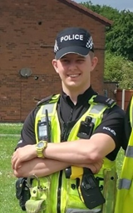
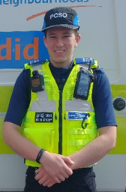
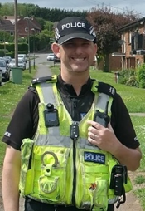
You said
- Vehicles doing stunts and being used in an antisocial manner in South Normanton
We did
- Issued a S59 warning ticket and a community protection warning in conjunction with Bolsover District Council.
- Carried out speed checks on Ball Hill
Crime prevention advice
- Park carefully, under a camera or attended car park that is well lit.
- Install CCTV to help deter burglars and secure vital evidence.
- Keep windows and doors closed, don’t leave any high value items on show.
PC GRAY 2582 PC WELLER 14548 PCSO GREGORY 13049 PCSO 17038 BARNES
Ways to get in touch with your local team
Call 101 if not an emergency
Visit https://www.derbyshire.police.uk/

Alternatively, you can contact us on Facebook.
https://en-gb.facebook.com/AlfretonSNormantonPinxtonSomercotesRiddingsSNT/

Upcoming events
- South Normanton cuppa with a copper
01/12/2022
10:00 – The Boundary

- Pinxton cuppa with a copper
01/12/2022
08:30 – Village Hall

Current priorities
- Antisocial behaviour on South street recreation ground.
- Off road motorbikes in South Normanton.
- Antisocial behaviour at the Boundary.
Safer Neighbourhoods
South Normanton and Pinxton

December 2022

